BX PARTNERS
The BX Bitcoin Model
A blended, rules-based approach to capturing Bitcoin's asymmetric upside,
without the white-knuckle ride.
Bitcoin doesn't reward the bravest investor. It rewards the most disciplined one. The BX Bitcoin Model is built on that conviction — two systematic strategies that work in concert, turning volatility from a threat into a structural advantage.

160.3%  Total return | Jun 2021–Jun 2026 | 21.3%  Ann. return vs. 13.7% for Bitcoin | 35%  Lower ann. volatility vs. Bitcoin | 17 pts  -59.6% Max drawdown vs. Bitcoin's -76.6%
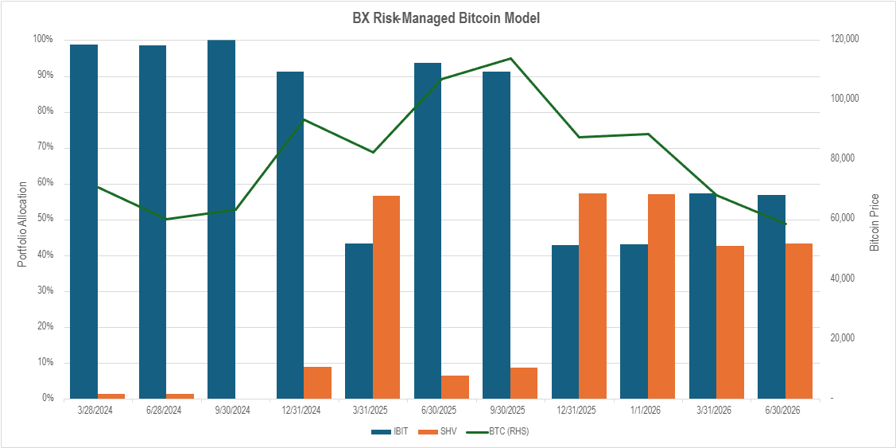
Portfolio Allocation Over Time
The chart shows how the Dynalogic strategy moves between IBIT (Bitcoin exposure) and SHV (short-term U.S. Treasuries) over time. When Bitcoin climbs to predetermined levels, the strategy takes profits and parks the proceeds in SHV earning yield while waiting. When Bitcoin pulls back, that cash rotates back into IBIT at larger sizes.
You can see this play out clearly in Q1 2025, when the strategy shifted over half the portfolio into SHV during a period of Bitcoin weakness, then gradually redeployed as conditions improved. It's a simple discipline: sell into strength, earn while you wait, buy back smarter.

1 The IBIT Rules-Based Strategy  Discipline over emotion  Most investors know they should sell high and buy low. Few actually do. This strategy removes that decision from human hands entirely — pre-programming when to take profits and when to re-enter, at every price level, before markets move.  • Tiered profit-taking: As Bitcoin climbs, the strategy systematically locks in gains at predetermined price levels — protecting capital before the crowd senses the peak.  • Stepped re-entry: When prices fall to predefined thresholds, accumulated cash deploys back in at larger size — buying conviction precisely where fear is highest.  • Dynamic position sizing: Trade size scales with price movement. A self-reinforcing discipline that capitalises on volatility rather than being victimised by it. |  | 2 The phaseinvest PDE Strategy  See the turning point before it arrives  Traditional momentum models are always looking in the rear-view mirror — measuring price across different regimes, lagging at the exact moments when speed matters most. The Phase Detection Engine (PDE) identifies structural breaks in volatility to establish the current market phase, then measures momentum only within that regime.  • Regime-based measurement: PDE establishes a unique Phase Date for each market environment — so signals are always fresh and never contaminated by a prior regime.  • Binary exposure rule: When momentum is positive: maximum Bitcoin exposure. When it turns negative: step back to a minimal base and allocate to Treasuries — preserving capital while keeping a toehold for rapid re-entry.  • Proven edge: PDE was originally built for equities, consistently outperforming benchmarks. That same precision is now applied to Bitcoin.

WHY THE 50/50 BLEND WORKS
Two uncorrelated signals  IBIT acts on price levels; PDE acts on regime changes. Because these signals move independently, they provide a natural hedge — when one misses, the other is already responding. | Complementary in every market  In a downturn, PDE reduces exposure early while IBIT scales in at lower tiers. In a bull run, IBIT banks profits at each level while PDE stays fully exposed. Together, they cover both sides. | Lower beta, better outcomes  The combination delivers a lower beta to Bitcoin than buy-and-hold — historically outperforming in both trending and range-bound markets with meaningfully reduced drawdowns.

Performance & Risk Analysis  Backtested / hypothetical results — common period for all strategies | Jun 2021 – Jun 2026  Daily log returns · Annualised to 252 trading days
OVERALL BACKTESTED PERFORMANCE
Strategy | Total return | Ann. return | Ann. volatility | Max drawdown
BX Bitcoin Model | 160.27% | 21.27% | 34.62% | -59.63%
phaseinvest (PDE) | 164.58% | 21.67% | 36.33% | -56.04%
Dynalogic (IBIT rules-based) | 134.27% | 18.72% | 38.05% | -64.92%
Bitcoin (buy & hold) | 89.27% | 13.73% | 53.63% | -76.63%
CALENDAR YEAR PERFORMANCE — BX MODEL VS. BITCOIN (BUY & HOLD)
2021 (partial) | 2022 — Bear | 2023 — Recovery | 2024 — Bull run | 2025 | 2026 (partial)
BX +39.0%  BTC +37.9% | BX -44.6%  BTC -64.3% | BX +122.5%  BTC +152.4% | BX +65.5%  BTC +107.8% | BX -8.9%  BTC -9.7% | BX -7.7%  BTC -29.4%
HOW THE MODEL BEHAVES ACROSS MARKET CONDITIONS
Market environment | IBIT rules-based | PDE momentum | Blended model outcome
Strong uptrend | Gradual profit-taking at price tiers; partially captured upside | Full exposure; captures the full macro move | Balanced upside with embedded profit-taking
Sharp reversal | Cash deployed at stepped re-entry levels; gradual re-entry | Rapid exposure reduction on regime change | Early drawdown protection with systematic re-entry
Sideways / range-bound | Frequent buy/sell at thresholds; generates alpha from volatility | Minimal exposure; preserves capital | Lower volatility with modest positive carry
Sustained downtrend | Cash accumulation; limited downside | Minimal exposure; protected downside | Strong capital preservation

Ready to explore the BX Bitcoin Model?  Speak with our team to learn how this strategy fits your client portfolios | BX Partners  bxindex.com  For Financial Professionals Only

Past performance is not indicative of future results. All figures are backtested and hypothetical — they do not represent live trading results. Actual results may vary significantly. This document is for informational and educational purposes only and does not constitute investment advice, a solicitation, or an offer to buy or sell any security. All investments involve risk, including possible loss of principal. Bitcoin and digital assets are subject to extreme price volatility, regulatory uncertainty, and market illiquidity. Investors must consult their own legal, tax, and financial advisors before committing capital. Performance metrics are calculated using daily log returns; annualisation uses 252 trading days per year. Maximum drawdown is the largest peak-to-trough decline over the stated period.

